Cub Scout Hiking Manual

Hike Number: 7

Hike Location: Appalachian Trail, US40 Trail Head Parking to Annapolis Rocks

Travel Distance: 46 miles from Ashburn Elementary School

Trail Head Location: AT parking area - 11196 Baltimore National Pike, Myersville, MD 21773. Near Boonsboro MD and Greenbrier State Park

Blaze Color: White

Map Number: 7-1, Supplement 7-2

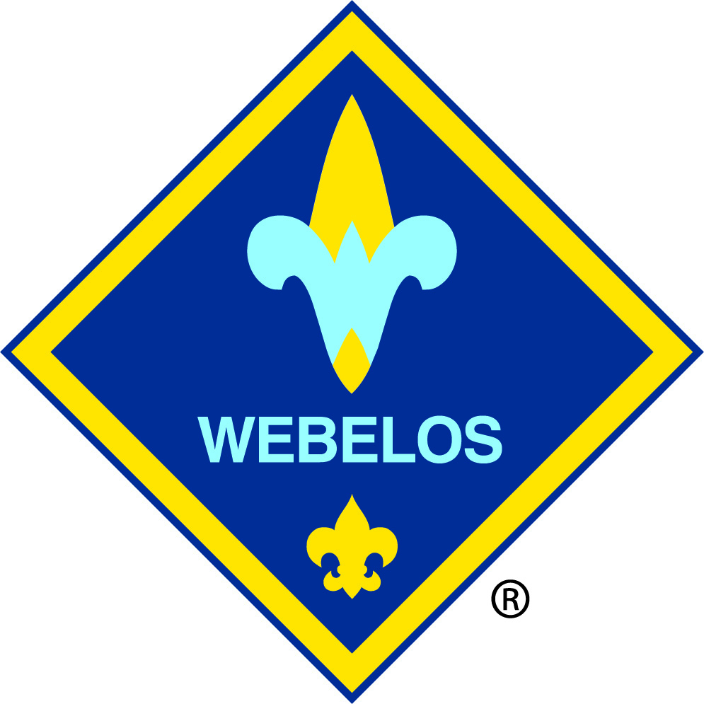

Ability Level:

Difficulty: Moderate 5.5 miles roundtrip

Description: Annapolis Rocks is a formation that overlooks western Maryland. It is a popular rock climbing and repelling location. There is also a backpacker campground. The hike begins on a connector trail at the west end of the US40 parking area. There will be an intersection about ¼ mile from the parking area where the AT turns and goes south over I70. Stay straight and you will be on the AT north. The trail is rocky in places with several erosion control logs installed at varying height and angles. The ascent is moderate but almost continuous to the top (840 feet of elevation) gain. The steepest part is at the beginning of the hike. After 2.5 miles you will reach the side trail for Annapolis Rocks (Blue Blaze) On the return trip, ½ mile before the end, take the side trail to the Pine Knob AT shelter (Blue Blaze). The Pine Knob Shelter trail is a loop and it will return back to the AT South of where you entered.

Facilities: Natural spring and privy at both the Pine Knob shelter and Annapolis Rock campground. Water requires purification.

Hazards: Use caution on the rock overlook to prevent falls. Trail can be muddy after it rains.

Cub Scout Adventure Requirements:

Webelos: Webelos Walkabout 1,2,3,4,6

Castaway 2b, 2c

Arrow of Light: Outdoorsman B 1,2,4